LAND ON SOUTH-EAST SIDE OF BEDFORD ROAD, GREAT BARFORD

DOCUMENT 1 – LAND REGISTER ENTRY

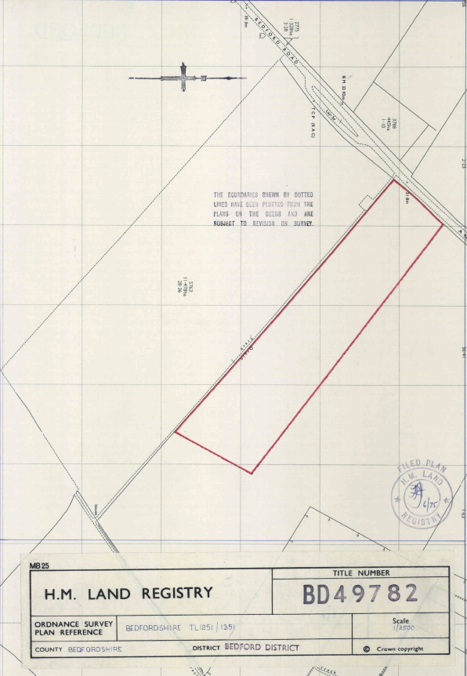
DOCUMENT 2 – EXTRACT FROM MINERALS PLAN

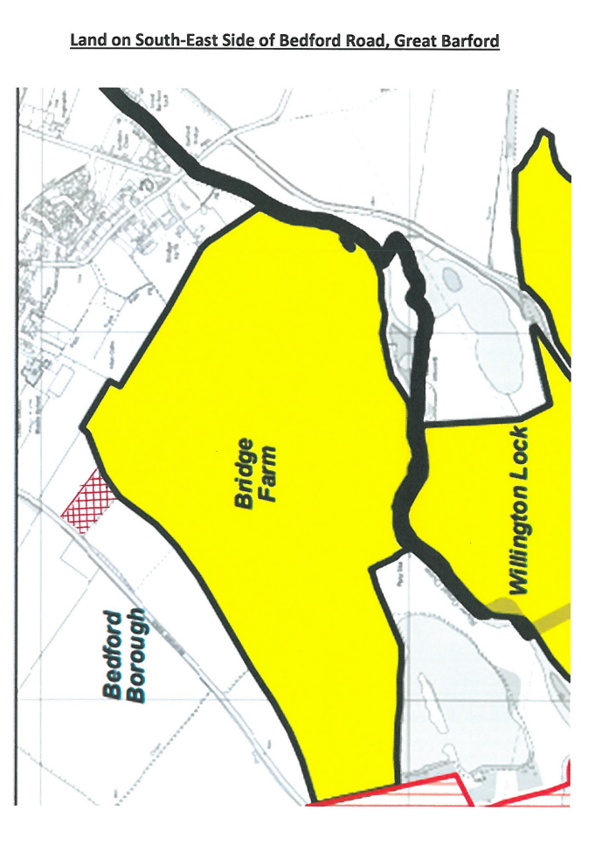
DOCUMENT 3 – EXTRACT FROM GREAT BARFORD NEIGHBOURHOOD PLAN
