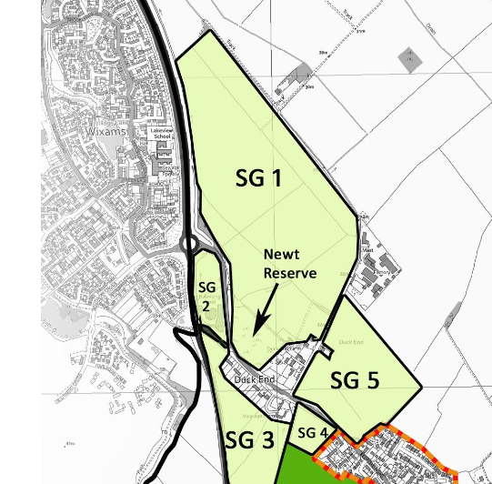
Reference: Paragraph 4.87 of LocalPlan2040

I object most strongly to any development in this area (SG1 in the above diagram). It was designated to be a strategic gap between Wilstead and Wixams in order to preserve their different identities.
Even more important is the likely detrimental effect any development will have on the habitat of the Newt reserve.

