Representation form for the Bedford Borough Local Plan 2040: Plan for Submission (Regulation 19 publication stage)

Please refer to the guidance notes available before completing this form.
Please return to Bedford Borough Council by 5pm on 29th July 2022.

This form has two parts –
Part A – Personal details: need only be completed once.
Part B – Your representation(s). Please fill in a separate sheet for each representation you wish to make.

Part A

1. Personal details* |  |  |  |  |  | 2. Agent’s details (if applicable)
*If an agent is appointed, please complete only the Title, Name and Organisation (if applicable) boxes below but complete the full contact details of the agent in 2.

Title
First name
Last name
Job title | Clerk
(where relevant)
Organisation | Shortstown Parish Council
(where relevant)
Address line 1 | 3 Saxon House End
Line 2 | Harrold
Line 3
Line 4
Postcode | MK43 7FS
Telephone number | 07870108315
E-mail address | clerk@shortstown-pc.gov.uk
(where relevant)

Part B – Please use a separate sheet for each representation

Name or organisation: Shortstown Parish Council

3. To which part of the Local Plan does this representation relate?
Paragraph |  |  | Policy |  | HOU18  HOU16  HOU17  DS2(S) ix  TC1(S) |  | Policies Map
4. Do you consider the Local Plan is :
4.(1) Legally compliant  4.(2) Sound |  |  |  | Yes  Yes |  | x |  |  |  |  |  | No  No
 |  |  |  |  |  |  |  |  |  |  |  |  | x
4 (3) Complies with the
Duty to co-operate Yes No

x

Please tick as appropriate
5. Please give details of why you consider the Local Plan is not legally compliant or is unsound or fails to comply with the duty to co-operate. Please be as precise as possible.
If you wish to support the legal compliance or soundness of the Local Plan or its compliance with the duty to co-operate, please also use this box to set out your comments.
Shortstown Parish Council has reviewed your draft local plan 2040 and after careful con-
sideration have the following comments. In the proposed 2040 Local Plan there are several
options proposing further development within Shortstown parish but due to the high levels
of development that Shortstown has already seen further housing beyond what has already
been built would risk Shortstowns rural character, further diffuse its small and fragile
centre, and risk the future of the historic airship sheds and Cardington airfi
eld.
We support the following policies found within it.
Policy HOU18 development of the former DVSA site. This policy would makes
good use of a brownfi
eld site currently surrounded by houses and we would welcome the
developer to open consultation with us at the earliest opportunity. The site is of limited
size and so while it would create additional traffi
c load compared to some other proposed
sites it would be of a more limited and manageable amount.
Policy HOU16 development on land east of Wixams
This proposes a cycle link to Shortstown/Cotton End that would be close to the North end
of Shocott spring and would be an ideal cycle route to Wixams station(when and if that
happens). Ideally it would connect to the existing right of way between Sefton
Fields and
Shocot Spring and/or with the cyclepath on the A600. Shortstown greatly needs rights of
way for walking and cycling to the east towards Elstow and Wixams. Ideally to connect
to the Bunyan trail and enable greater opportunity for travel on bicycle of by foot for
residents of the borough.
We oppose the following policies.
Policy HOU17 Development at College Farm. Over the few years Shortstown has
been targeted for massive development. Between 2014 and March 2021 901 houses have
been built in the parish. When the Cardington Air
field development to the North of
the sheds has been completed another 592 houses will have been added. Once that is
complete that will be 1493 houses added to the parish since 2014. While the development
of RAF Cardington did include a notional village centre this has been slow to develop
and Shortstown is still severely de
ficient in key services for the level of households now
within the parish. The Transport Model discussed in supporting documents shows the
A600/A421 junction is already forecast to be saturated and additional housing would only
make things worse. For this reason we would also object to large development within
the parish of Cotton End as that would also massively increase the strain on our limited
transport infrastructure.
The only data we could
find via the DfT for traffi
c on the A600 is available at the following
URLs
Count point 77216 https://roadtraffic.dft.gov.uk/manualcountpoints/77216
Count point 81517 https://roadtraffic.dft.gov.uk/manualcountpoints/81517
Both of these points are on Tinkers hill on and the reason for changing ID is not known
but they are both in approximately the same location. Discarding the estimated tra
ffic
numbers and plotting only those that were manually counted we can see that there has been
signifi
cant traffi
c growth on the A600. This is shown in the fi
rst fi
gure. It is a reasonable
conclusion that this signifi
cant increase in traffi
c coincides with and is caused by the recent
housing increases in Shortstown. Given the very large site in Shortstown to the North East
of the two historic airship sheds which is at an early phase of construction additional large
tra
ffic growth is only to be expected.

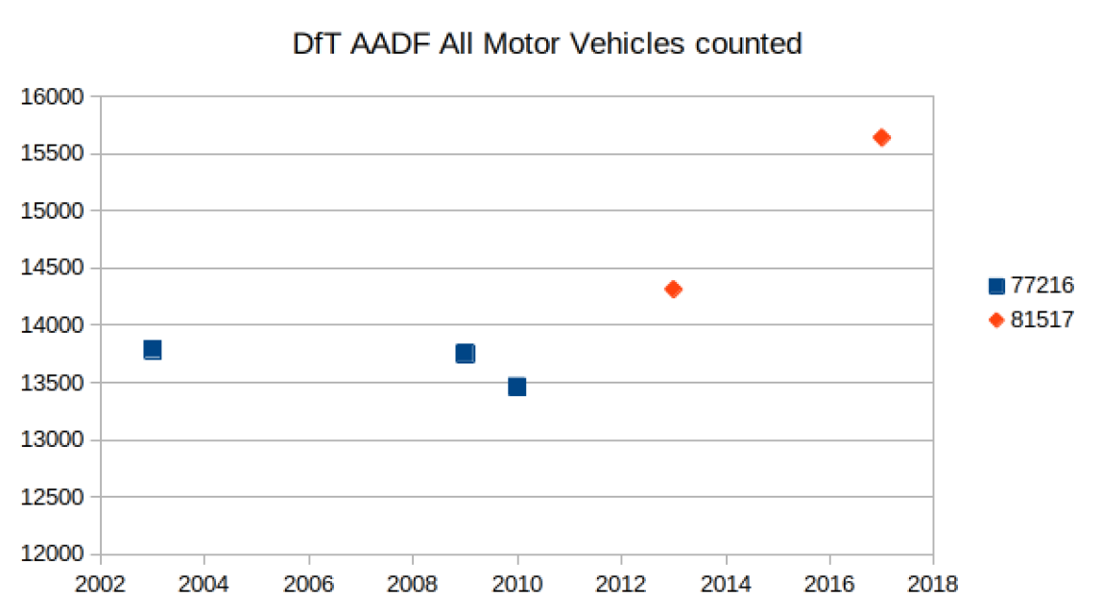

As can be seen in the second included
figure Shortstown has seen recent rapid change over
recent years and when the additional development to the North of the historic sheds is
included this pushes the developed area within the parish to roughly 25% of the parish.
This land use estimate was calculated using GIS software and creating polygons around
each development one at a time to allow both the area of each development to be calculated
and also to understand the cumulate area used for housing and its growth over time. The
data is available on request. The proposed College Farm and Shorts Park developments
would completely change the character of the parish and ruin the future of the sheds and
air
eld for movie and airship use.

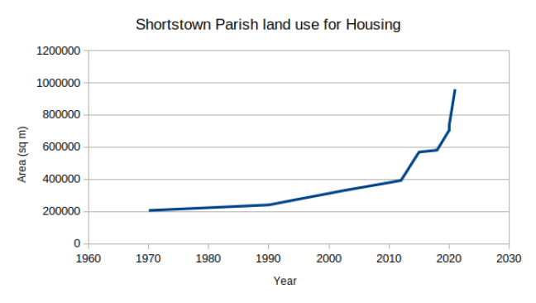
Beyond that it is a reasonable conclusion from the existing growth in traffi
c and services
demand we have seen College Farm would increase these problems still further and we have
not yet even seen the full impact of developments that have already been approved.

Policy DS2(S) ix. Expansion of Shortstown to the west. In keeping with our
objection to Policy HOU17 we object to expansion of Shortstown to the west. Shortstown
has seen substantial additional housing but no improvement of transport links and the
impact of large sites currently in build has not been reviewed. A pause is required in order
for traffi
c, services, and related items to be stabilised and the as yet unknown new higher
level. We can always proceed with additional developments later but once approved they
cannot easily be cancelled after the damage they cause has been revealed.
Policy TC1(S) We oppose the characterization on page 53 of our connection to Bedford
as good. With the exception of portions of the industrial area within the parish north of
the A421 we are connected to Bedford via a single road and while it is designated as an A
road it does not represent a good connection. We also have one bridleway under the A421
but this can only be reached by walking along roads without pavement through Harrowden.
Shortstown is dependent on the A600 for professionals to commute to work either North
towards the A421 and Bedford or to the South. However this single link has proven to be
vulnerable to disruption going as it does through an accident blackspot at the junction with
Harrowden Lane. Public transport is currently insu
fficient except for accessing Bedford for
occasional shopping. This creates a tension between the notional Borough policy to reduce
car use with transport infrastructure that discourages public transport use for commuters.
We oppose our designation in Policy TC1(S) on page 86 as a Key Service Centre. As
previously discussed given our resources and services we are more of a neighbourhood
centre.

(Continue on a separate sheet /expand box if necessary)
6. Please set out the modification(s) you consider necessary to make the Local Plan legally compliant and sound, in respect of any legal compliance or soundness matters you have identified at 5 above. (Please note that non-compliance with the duty to co-operate is incapable of modification at examination). You will need to say why each modification will make the Local Plan legally compliant or sound. It will be helpful if you are able to put forward your suggested revised wording of any policy or text. Please be as precise as possible.
Removal of the following policies related to Shortstown:

Policy HOU17 Development at College Farm.
Policy DS2(S) ix. Expansion of Shortstown to the west.
Policy TC1(S)

(Continue on a separate sheet /expand box if necessary)
Please note. In your representation you should provide succinctly all the evidence and supporting information necessary to support your representation and your suggested modification(s). You should not assume that you will have a further opportunity to make submissions.
After this stage, further submissions may only be made if invited by the Inspector, based on the matters and issues he or she identifies for examination.

7. If your representation is seeking a modification to the plan, do you consider it necessary to participate in examination hearing session(s)?
 | X | No, I do not wish to  participate in  hearing session(s) |  |  |  |  |  |  |  | Yes, I wish to participate in hearing session(s)
Please note that while this will provide an initial indication of your wish to participate in hearing session(s), you may be asked at a later point to confirm your request to participate.

8. If you wish to participate in the hearing session(s), please outline why you consider this to be necessary:
Please note the Inspector will determine the most appropriate procedure to hear those who have indicated that they wish to participate in hearing session(s). You may be asked to confirm your wish to participate when the Inspector has identified the matters and issues for examination.

