OVERVIEW

This document represents the considered response of Wilshamstead Parish Council (WPC) to the strategic proposals set out by Bedford Borough Council (BBC) in their consultation conducted June to July 2022.

Whilst the Council understands the position Bedford Borough is in, by following the government formula for the calculation of additional housing BBC are obliged to plan for a growth rate far in excess of that which the borough can sustainably accommodate. The resulting huge number of new houses located South of Bedford would result in the urbanisation of this area and the removal of the rural nature of this part of the Borough.

For this reason and other reasons spelled out later in this document WPC strongly object to the proposals.

Parish Council Approach to the Consultation
Wilshamstead Parish Council is experienced in understanding the due process relating to public consultations and is therefore mindful of the importance of presenting clear and robust evidence at all stages, but in particular at this part of the consultation process, to ensure that Wilshamstead Parish Council makes clear its view as the first tier of local government. The Parish Council, has a further role as always, serving its electorate and ensuring they are supported throughout this phase, so considerable work has been done ensuring they are not only aware of the proposals and their direct impact on Wilstead, but also in engaging effectively in the consultation process.

The Parish Council also feels at this stage in light of the Local Plan shortly being taken forwards to government inspection, that with such a significant development earmarked and set out in the parish of Wilshamstead within this strategy document, that it is important to reiterate items that have previously been expressed.

Wilshamstead Parish Council, as usual, has been extremely pro-active in attending BBC led consultation events directed at local parishes, as well as the various public engagement activities within the consultation run by BBC. There has been a thoroughly review of the consultation documents, throughout the consultation period, as Parish Councillors have strived to understand more about the many different technical and complex items being considered. This is in addition to a huge number of important accompanying planning policy documents which will shape the future of Wilstead and communities across the Borough.

The Parish Council has facilitated a number of different ways to encourage Wilstead residents to engage with this consultation process, whether directly to BBC representatives or through feedback to Wilshamstead Parish Councillors. Throughout this consultation it has remained an absolute priority that all in Wilstead are aware of the enormity of the proposals, and that they can have their say and their voice heard. This has included using a village electronic circulation list, website publications and social media posts. Furthermore, signs were placed around the village to ensure those passing through (of which there are many every single day already) were aware of the potential impacts. These signs were sabotaged a few days later showing that personal interest is driving the presentation of the proposed sites in Wilstead. In addition there have been multiple communications made to the village population through the village magazine along with residents being welcomed to the July Parish Council meeting. The Parish Council also arranged a specific drop-in session on Sunday 10th July at Wilstead Village Hall to enable residents who had questions and/or required assistance with understanding to engage in responding to the consultation. The Parish Council knows the proposed allocations within this consultation are of interest to residents as over 130 attended the drop-in session.

It is also important to recognise that Parish Councillors are lay persons, volunteering their time, trying their best to review, consider and digest all the information relating to many different technical aspects of this Local Plan process. In addition, the volume of associated policy documents being consulted on, which again are also complex, however, are fundamentally crucial in the important role they play in the wider context of the development strategy.

As a result, it was important to Wilshamstead Parish Council that they focus on the impact the proposed allocations have on Wilstead - the area known best to Councillors.

RESPONSE SUMMARY

WPC objects to a number of different policies of the Plan document, these will be expanded upon later in this document under the requisite headings.

- Misleading consultation representation
The Wilstead community feel it is important to recognise that the document has been misleading in how the specific site policies have been named which has resulted at best in misleading representation and is possibly legally unsound.

- Capacity of Existing Resources
Any further development threatens the ability of existing resources to cope as these are often inadequate for existing residents and community governance issues not addressed in the Plan document. There is particular concern about build-up of traffic approaching the A421 from the A6.

- The Need for Housing, Sustainable Development and the Environment
In this Section WPC expresses its support for questioning the overall number of new houses required.
We also repeat from our Neighbourhood Plan what sustainable development means for the village and cannot see how the draft Local Plan addresses these requirements in any way.

- Potential adverse effect of major development in Wilshamstead Parish
There have previously been many concerns expressed about the Plan generating a large number of additional houses in Wilstead, which would result in a complete change of character of the village. Reasons against any substantial development are many and listed under this heading later in the document with focus on Policy HOU15 Land South of Wixams, Policy HOU16 Land at East Wixams and Policy HOU17 Land at College Farm, Shortstown. In addition Policy EMP 5 Pear Tree Farm Elstow together with the plans in Central Bedfordshire add to the proposal for surrounding Wilstead with development.

- Settlement Hierarchy
The Parish Council recognises that some development may be unavoidable in Wilstead but would wish this to be restricted to that suited to a Rural Service Centre and to be consulted on any location. Assumptions made in the Bedford Borough Settlement Hierarchy continue to be based on inaccurate data both for Wilstead and for Wixams.

- Coalescence
The increasing size of Wixams, Shortstown, Elstow and Cotton End threatens the separate identity of Wilstead which needs to be clearly maintained. During the life of the Local Plan 2040 this will result in the creation of an “urban sprawl” to the South of Bedford, without the necessary infrastructure or resources .

- Neighbourhood Plan
The village has been preparing a Neighbourhood Plan since February 2017 and has had problems with support for the process during the Covid pandemic. Consequently it would not wish the Local Plan to pre-empt the important proposals already in draft form which include the allocation of Important Green Space designation to many of the sites identified under the “Call for Sites” process.

- South of Bedford Policy Area
The Council has set out its response to this specific supplementary planning policy document.

- Marston Vale Supplementary Planning Document
The Council has set out its response to the Developing in the Forest of Marston Vale Supplementary Planning Document which is a planning policy document being prepared by Central Bedfordshire Council and Bedford Borough Councils.

- Conclusion
This sets out the Parish Council overall feedback to the consultation, reiterating reasons for objection.

SECTION 1: MISLEADING CONSULTATION REPRESENTATION

The Parish Council immediately on publication of the formal consultation and related publicity material raised concern directly with Planning Policy Officers at the local authority on the misleading naming of proposed local plan locations as a “Wixams Extension”. Officers outlined that sites were being classified by their geographical locations, this however, has not been a helpful representation for the Wilstead community and it was noted at our open day repeatedly that the Local Plan was misleading and confusing as many residents believed it was a further extension to Wixams on the other side of the A6. Both HOU15 and HOU16 should have been known as Land West of Wilstead (HOU15) or Land North of Wilstead (HOU16), just like policy HOU5 Abbey Field, West of Elstow which makes a clear reference to the parish it is in. In response to a question during an on-line discussion about this misrepresentation the Planning Department replied that they were sure Wilstead Parish Council would make it clear to Wilstead residents that the proposals were within the Wilshamstead Parish. This is unacceptable. The Parish of Wilshamstead is severely affected by the proposals in the Plan in that it appears to propose reducing the size of the Parish by approximately one fifth, significantly impacting upon walking routes, biodiversity and dramatically increasing through traffic whilst also transitioning this land and the applicable services within it to Wixams. Nowhere in the document is this made clear.
Wilstead is mentioned only 7 times in the document and only in terms which support the preservation of the village in its current form.

It could be predicted that in shifting one fifth of the current Parish of Wilshamstead to Wixams the Wilstead community would not only suffer the effects described at length within this document but would also not benefit from any Community Infrastructure Levy received from developers that could act as some mitigation for the loss and overburdening of current resources.

The inaccurate naming of the two proposed allocations within the draft Local Plan and consultation documents is a significant issue in that it is misleading the public and inaccurate in its nature, casting doubt on the accuracy of the Plan as a whole and something that may become subject to legal challenge at a later stage.

At most, members of the public will glance or briefly scan such a local authority document at best, whether that is the literature produced in text, or visual format. For many, on doing that, it appeared that the Local Plan 2040 document aligned with the adopted and well supported Wilshamstead Neighbourhood Plan allocation of no additional housing.

However, both HOU15 and HOU16 clearly sit entirely within the parish boundary of Wilshamstead, as illustrated on the map below.

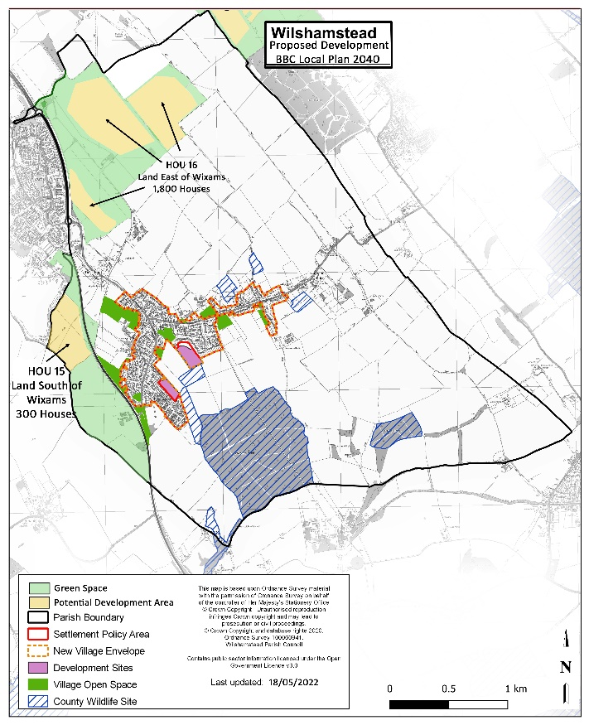

This misrepresentation of information will have resulted in many not understanding the proposals. Often, when individuals see no direct impact, they do not go into a more in-depth review of the consultation and therefore are unlikely to give feedback or engage in the consultation process. This is relevant to those that live in Wilstead, as well as those who live nearby in Wixams who have also been misled. The knock-on impact of this inaccurate site naming will also spread beyond the nearest settlements, with many across the borough believing that the proposed developments are in Wixams, which is well known in terms of having been a new town, created to serve a growing new community. Totally distinct from ‘Wilstead’ which is recognised across the borough as a rural village.

Removing Wilstead from the policy site names, feels like an attempt from the local authority to disguise significant development for the village community and to directly mislead the public in order to establish new development without significant objection.

SECTION 2 : CAPACITY OF EXISTING RESOURCES

Overview
The village has already had to accept development of 105 houses as its contribution to the Local Plan 2030. This is an increase of over 10% which has already threatened to overwhelm local facilities, such as the local village school and the secondary school at neighbouring Wixams, both of which are at full capacity.

Local Plan 2040 Specific
The village is now faced with Policy HOU15 and HOU16 which bring an increase of 2,100 houses over the lifetime of this new Local Plan. It is unclear in the consultation on how Wilstead is expected to cope with such an influx of housing development as it certainly does not have the infrastructure to manage this, and the proposed developments do not bring such facilities to support the drastic growth without substantial funding which, in the past, has not been forthcoming.

Furthermore, the road network locally is already an issue with Wilstead being the connecting road from Wixams (as it is today) through to the A600. Notable speeding issues have not yet been sufficiently addressed by BBC and we are now faced with a potential increase in not only traffic once the site is built, but also a huge amount of polluting vehicles bringing goods and materials, workmen and equipment during build.

It is not clear from this document how such a rural village would cope with a population increase of circa 5,000. It might be argued that such densely populated areas may look to Wixams Town Centre, however, that still remains some time off in the future. Initially new residents will look to Wilstead or Village 1 at Wixams, both of which have very limited facilities (see the argument below on inaccurate Settlement Hierarchy evaluation).

Whilst the consultation document places generic aspirations for the development growth areas it is important to remember there are specific local factors that need to be taken into account. Development cannot be in the direct path of water draining from the Southern escarpment (Greensand Ridge) or in the lower levels north of the village centre, which are shown on Water Authority documentation as at risk of flooding from drainage ditches. Each housing policy area has an overarching ‘mitigation required for all sources of flood risk where necessary’ but they are site specific. Cumulative impact does not appear to be referenced which has a knock-on effect to all residents who can then find water draining problems occurring. Since the development at land off Whitworth Way known as Wooding Way the knock-on effect has been noticeable further afield in the village.

Public transport or cycling are not realistic alternatives for people in the area to get to work or to go shopping. The bus service in Wilstead is very limited. There is no East to West or West to East service despite the village stretching nearly 2 miles in that direction. In addition, bus stops for the service to Bedford are located more than 800m from the majority of residents. The existing bus service along Luton and Bedford Roads in Wilstead is unreliable and infrequent leaving gaps of one hour at many peak times.

For cycling or walking it would be necessary to cross the A6 from HOU 17 to reach existing facilities in Wixams which would be extremely dangerous and the draft Plan shows no suggestion as to how this danger may be mitigated.

A full study was commissioned by the Borough Council for the current Local Plan 2030 on the effect of proposed additional traffic on the A6 approaching from the North into Bedford. This was the main reason that large developments north of the town have been ruled out. The research carried out by AECOM on the effect of the increase in traffic approaching from the South if these developments were to go ahead is inadequate and does not show the effect of so much more traffic being generated by the proposed developments in Wilstead, by the cut-through traffic from, and to, the A600 and the large developments proposed close to the A6 by Central Bedfordshire Borough Council. The build-up of traffic approaching the A421 or the new Wixams station would be extreme and no proposals are evident of mitigating road changes. There is also no evidence of any air quality targets or measures to mitigate the impacts of climate change beyond very high level statements and an ever increasing amount of tailbacks on the northbound A6 as it meets the A421.

The biggest cumulative impact that will be seen within the parish will naturally be around highways and further increases in traffic on the already overwhelmed existing busy rural roads which have become very congested at school opening and closing times throughout the rush hour period as the village is used as a ‘rat run’. The Parish Council have extensive data from local surveys, Police and local authority survey with the problems experienced, particularly along Cotton End Road. Traffic originates from outside the village and is an indication of how development outside of the Parish Council’s area has in turn adversely affected the resources within the village. There is still no local Health facility in Wixams or Wilstead and the weekly access to doctor’s services in Wilstead has been discontinued. In addition the number of new houses proposed in the Central Bedfordshire Local Plan will mean that doctors used by Wilstead residents in Ampthill will become even less available. There is no indication in the draft Plan as to how the additional 28 GPs identified in the AECOM Infrastructure document could be recruited to serve the number of new residents proposed in the South of Bedford Policy area.
Further concerns exist around schooling. A 9-form entry (FE) secondary school and two 2-FE Primary Schools within HOU 16 is an ambitious target that would require massive funding and resources that would not be forthcoming in the short-term, thus putting even more pressure on existing schools in the area which are already at capacity.
Infrastructure concerns are further addressed in Section 8 of this response addressing the South of Bedford Policy contained within the proposed Plan.

SECTION 3: THE NEED FOR HOUSING, SUSTAINABLE DEVELOPMENT AND THE ENVIRONMENT

Wilshamstead Parish Council appreciate the work behind the document from the Campaign for Rural England dated July 2022 in which they question the need to find 27,100 additional houses between now and 2040. WPC accept that BBC has made the point to the Government that they “are obliged to plan for an excessive growth rate far in excess of that which the borough can sustainably accommodate.” But feel that the Borough should not just lie down and accept that no flexibility in the numbers can be shown.

The National Planning Policy Framework (NPPF) states that pursuing sustainable development includes making it easier to create jobs in villages, promoting gains in biodiversity, achieving better quality design, improving people’s quality of life and providing a wider choice of high-quality homes. It is unclear how these can be achieved based upon the broad terms included in the draft Plan.

Within the Wilshamstead Neighbourhood Plan we list what sustainable development should mean for the village. It should be:
- At an appropriate scale and in locations where it would support the community,
- Of a high standard of design, reflecting the rural and historic character of the surroundings,
- Contributing towards community infrastructure,
- Providing superfast broadband (fibre-optic) connections,
- Ensuring that there is no increase in the risk of flooding,
- Meeting contemporary construction, energy efficiency and water management standards,
- Located and designed to enable safe walking and cycling to local services and facilities, preferably within a 400m radius of those locations.

WPC cannot find the detail within the draft Local Plan of how any of these can be achieved.

In addition the Neighbourhood Plan states that the following adverse impacts must be avoided:
- Reduction in the physical separation between the village and Wixams,
- Avoidable intrusion into open countryside,
- The loss of or damage to wildlife habitats and hedgerows and trees,
- The loss or inappropriate diversion of public rights of way,
- A loss of amenity for existing residential properties and reduced efficiency for nearby businesses,
- Overloading existing utilities and services (water, drainage, sewerage and waste).

None of these concerns appear to have been addressed by the draft Local Plan 2040 and a number are directly contradicted by proposals in that Plan.

WPC support the CPRE Bedfordshire proposal that all open green space within new housing development should be handed over to Town & Parish Council's for long term maintenance and not held onto by developers who charge residents much higher maintenance costs. We receive regular complaints about this in existing developments in the village. We agree with CPRE and can ourselves find no reference in the Draft Plan to any steps taken to address this

Paragraph 6.62 of the Draft Plan refers to “environmental net gain” but nowhere can we find an explanation of what action is to be taken to achieve this.

Other aspects of sustainability are that you should not use sites that are valuable from an agricultural/environmental/recreational perspective for development. All of the land proposed for development is on key agricultural land and HOU 16 borders an important footpath used daily for recreational activity and a Community Woodland planted recently for that very purpose.

SECTION 4: POTENTIAL ADVERSE EFFECT OF MAJOR DEVELOPMENT IN WILSHAMSTEAD PARISH

Village Overview
There are only approximately 900 houses in the village (plus 196 park homes), therefore any substantial development would completely alter the character of the community and overwhelm its already overstretched facilities. The addition of 2100 houses would mean the village housing number would become three times the current size until such time as the land is annexed off into Wixams at which point the village would become dwarfed by its neighbour and would further lose its small, rural feel.

Wilstead is a rural community, which it is vitally important to retain. Securing its rural feel is essential and emphasised repeatedly in responses from villagers to the consultations on the Neighbourhood Plan. This should be achieved by maintaining a large number of green spaces, strategic gaps between settlements and important views into the surrounding open countryside.

The village has consisted for centuries of separate “Ends” (e.g. Duck End, Church End, Littleworth). These should remain separate to preserve that rural Bedfordshire heritage, not only in the timeline of this Plan but for future generations to come. The map on page 67 of the Plan shows arrows to denote “Local Gaps”, This completely ignores the fact that the Duck End community is next to the proposed area for development under HOU 16.

The existing, very stretched, “Ribbon Development” of Wilstead would not tolerate further development on its edges (or moreover on land completely disjointed from the traditional development style seen to date) without these developing into separate communities in themselves and necessitating additional car journeys and the further and unnecessary use of natural resources which is in itself unsustainable and unnecessary. Wilstead is a settled community and the Parish Council do not wish development to introduce separation, meaning therefore, that any development to the village would have to be more central and consistent with the existing size of the village. It should be noted that further development in the village has been managed successfully to that end to date whilst simultaneously maintaining a rural and peaceful area.

Wilstead is incredibly lucky to have a wonderful range of footpaths and bridleways and quiet country roads within the parish; perhaps most notably the historically important John Bunyan trail. They are very popular with cyclists, walkers, bird watchers and horse riders. A wide range of people not only from Wilstead but also surrounding villages, including Wixams, use them to enjoy the tranquillity, the wildlife, the views or just to get exercise and for mental well-being. There are 11 miles of footpaths and bridleways within the Parish Footpaths, the use and enjoyment of rights of way would be detrimentally impacted with the proposed allocations, especially as the proposed HOU 16 would adjoin a much-used footpath (part of which is on the John Bunyan trail) and HOU 15 would be dissected by an existing footpath.

Proposed Allocations Objections
Substantial development has been included in the Local Plan document with Policy HOU15 and Policy HOU16. The Parish Council is also mindful of the sizeable allocation for Policy HOU17 Land at College Farm, Shortstown which will be addressed as well in this response.

The Borough Council indicates that as a result of previous consultation it is going ahead with a recommendation for “Option 2b” of its previous proposals. This Option refers to an additional 5,500 houses in Kempston Hardwick, Stewartby and Wixams and 1,500 spread between Wootton, Kempston, Shortstown , Cotton End and Wilstead. Policies HOU 15, HOU 16 and HOU 17 show 3,100 houses for Wilstead and Shortstown alone. Option 2b is therefore not what is being proposed and the detail within the proposed Local Plan has therefore not been consulted upon.

All three of the allocations above if taken forwards as strategic growth options by the local authority, would most likely consist of estate-type development which would be out of character with the rural, multi-age and mixed style of the current range of dwellings.

In addition for sites HOU15 and HOU16 if they were to be developed it would be mean for both major developments in Wilstead it would necessitate people travelling by car into other communities, as these resources do not exist locally in the parish. Examples include:
- Schooling (insufficient places available locally)
- Shopping (local store cannot supply the range of goods required)
- Health facilities (none locally)
- Onward bus or train travel (very limited services)

Policy HOU 15 Land South of Wixams (i.e. West Wilstead)
In addition to the Parish Council objecting to this proposed allocation for the planning policy reasons set out above, the Parish Council wish to highlight in particular for this site, the detrimental impact in terms of coalescence (see Section 5 below). The location of this site is key to retaining segregation of the two distinctively different communities. Development in this area places a huge risk to Wilstead and the Longmeadow Drive area of the parish becoming subsumed as part of Wixams.

The Parish Council also feel it is important to highlight specific areas of the associated planning policy which if the site remains allocated, must be amended prior to Secretary of State scrutiny.

Paragraph 4.86 makes no reference of the site within Wilstead parish or its proximity to Wilstead, these omissions are not acceptable.

The policy wording makes a brief reference to a long-term buffer between Wixams and Wilstead, however, this is not reflected in Figure 8 of the consultation document within the site boundary. This is concerning as in many other site maps illustrating proposed allocations there has been distinct reference already included of important areas identified as key open spaces even at this strategic level. Such safeguarding of areas can be included at this stage of the Local Plan. Again this omission is concerning for the Parish Council.

In light of the landowner/site agent representations within the ‘Call for Sites’ process it is clear the aspirations for this site are considerably more than the 300 proposed allocation. Given recent experiences of sites that have come forward, the Parish Council are mindful it is often the wish of the developer when bringing a site forwards to place as many houses on as possible to maximise revenue output. It is therefore reasonable that if this site remains included that it must have written into the strategic policy robustly a definite number of houses, alongside the key earmarked open space areas to act as a strategic buffer. Without this change and inclusion within the policy there is no safeguard or protection for the site to not be fully developed and given the site has capacity to hold well over 1,000 houses this is really a concern for the Parish Council.

Policy HOU15 wording is not clear enough on a number of important factors that must be stated within the overarching policy if this site goes forward. There are too many ‘loose’ words which during the development of Wixams resulted in so many expectations not being met. Together with the limited local authority powers, it caused a lot of distress that facilities were not being progressed in a timely manner and resulted in many ultimately never being delivered or being many years late.

The Parish Council feel that there needs to be more included with the Transport Assessment, with higher expectations and aspirations for further enhancements to the local network to maximise more sustainable methods of transport, such as a clear and specified Local Transport Decarbonisation Plan, following the Government’s commitment to Net Zero, the national EV Infrastructure Strategy and supplementary Transitioning to zero emission cars and vans: 2035 Delivery Plan which will incorporate not only the traffic related to the construction activity (which typically sees large diesel-powered HGVs operating) but also the longer-term operation of fleets and commercial vehicles in these areas. This plan must include the provision of sufficient e.g., charging hubs, destination charging and on-street charging to supplement the now mandatory home charging sockets. It should also be a requirement of the development to provide sufficient non-motorised options for sustainable transport, such as cycling routes and walkways away from the roadside (for safety and emissions reasons).

In item iv. it talks of ‘provision of a mobility hub’, this needs to be defined in more detail as otherwise it becomes just a piece of land that is allocated but has nothing of any useful benefit on it. Infrastructure is critical to ensuring a community can grow. Further to this, the provision of energy for the site should be mandated within the policy document to come from localised generation.

Again there needs to be more robust wording in items vi. viii. and ix. With some more substantial statements referenced.

Item x. makes reference to preserving and enhancing heritage assets and their setting, ‘including assets located in Duck End and Wilstead.’ Whilst it is important that Duck End is recognised as an important area which includes 3 listed buildings, there are plenty more assets in close proximity to this site allocation that should be included and specifically named in the policy wording, including All Saints Church and 19 other Listed Buildings within the Village.

Policy HOU16 East of Wixams (i.e. North Wilstead)
Likewise for this proposed planning policy, in addition to the Parish Council objecting to the proposed allocations for the overriding planning policy reasons set out above, the Parish Council wish to highlight in particular for this site, concerns about the development area as illustrated on Figure 8.

The location of this site is a real concern as it sets total precedent for high density estate development east of the A6 within Wilstead parish. For many years land that side of the A6 and the village road into Wilstead has been put forward for planning, and refused, rightly so. Such an allocation with Policy HOU16 would have a significant knock-on effect.

The proposed Settlement Policy Area for HOU16 also extends a long way eastwards, again a concern given the large land masses along Cotton End Road in Wilstead which have received planning applications for housing development in the past. Whilst they have been refused previously, it does bring concern that this allocation could set a precedent.

The Parish Council also feel it is important to highlight specific areas of the associated planning policy which if the site remains allocated, must be amended prior to Secretary of State scrutiny.

Overall, the two largest areas marked on Figure 8 identified for potential housing development are situated a considerable distance away from the A6. Figure 8 clearly shows that development abuts the A6 fully on the western side. It seems more logical and natural, that the third potential development area currently located on the south west corner of the proposed allocated site, is moved upwards to be in line with the larger two masses as depicted by the red arrow below. Alternatively if this revised location is not acceptable, being then situated in a Flood Zone it should be removed altogether.

Equally for this Policy HOU16 site the Council feel in light of the landowner/site agent representations within the ‘Call for Sites’ process it is clear the site can hold significantly more than the 1800 proposed allocation. Given recent experiences of sites that have come forward, the Parish Council are mindful it is often the wish of the developer when bringing a site forwards to place as many houses on as possible, to maximise revenue output. It is therefore reasonable that if this site remains included that it must have written into the strategic policy robustly a definite number of houses, alongside the key earmarked open space areas to act as a strategic buffer. Without this change and inclusion within the policy there is no safeguard or protection for the site to not be fully developed and given the site has capacity to hold enough for a new town this is really a concern for the Parish Council.

Again the Parish Council feel that Policy HOU16 wording is not clear enough on a number of important factors that must be stated within the overarching policy if this site goes forward. There are again too many ‘loose’ words which during the development of Wixams resulted in so many expectations not being met, alongside the limited local authority powers, it caused a lot of distress that facilities were not being progressed in a timely manner and many ultimately never were delivered.

Paragraph 4.87 makes no reference of the site within Wilstead parish or its proximity to Wilstead, these omissions are not acceptable.

The Metrological Research Unit at Cardington is referenced, having tried to better understand the impact this has on the site, in terms of planning policy, this is not clear. It would be reasonable for such an item considered to be so significantly important to be mentioned in the planning policy that somewhere there is clarity on what such a reference actually means along with the types of mitigation that will need to be factored in. The reference is made in both paragraph 4.87 as well as Policy number i. so it must be an important item.

Item iii. references transport improvements are required, in fact the development is dependent upon it. Again the policy wording is insufficient and unclear, this needs to be defined.

The Parish Council feel that there needs to be more included with the Transport Assessment point number iv. it seems illogical that a site for 1800 houses has less requirements stipulated in the associated policy than Policy HOU15 which is to have 300 houses. Surely as a bare minimum the four bullet points contained within HOU15 should be referenced in HOU16. Along with, as mentioned previously, the local authority needing to have higher expectations and aspirations for further enhancements to the local network to maximise more sustainable methods of transport. As highlighted in the above section, all such development activity should be mandated to have localised, on-site generation to mitigate the impact of the site by ensuring renewable energy is used in the local transport and heating solutions from the point of breaking ground and beyond.
In item vi. it talks of ‘provision of a mobility hub’, this needs to be defined in more detail as otherwise becomes just a piece of land that is allocated but has nothing of any useful benefit on it. Infrastructure is critical to ensuring a community can grow.

Again there needs to be more robust wording in items vii. viii. ix and x and education infrastructure. Previous issues as outlined already with empty spaces for facilities to be built when infrastructure needs to be available to support the community before it grows.

Item xii. makes reference to preserving and enhancing heritage assets and their setting, ‘including assets located in Duck End. In Policy HOU15 this statement referenced ‘and Wilstead’, it appears inconsistent that there has been no reference of Wilstead which contains 23 listed buildings that will need protecting.

It is also noted that there is no policy wording as in Policy HOU15 stating ‘submission of a wildlife and habitat survey with appropriate mitigation and enhancements.’ The Parish Council request this must be included if the site is taken forwards, it is an extraordinary omission given Policy HOU16 is adjacent to a community woodland area in Duck End which also has a designated area for Great Crested Newts - very much a protected species.

The Parish Council would like to reiterate the concern with this allocation with regard to its close proximity to the Duck End part of the village. The boundary abuts this unique setting of dwellings which are all of historic value. The houses along the western side of Bedford Road will have their outlook changed forever, so this reiterates the importance to protect those views as much as possible by moving or removing the proposed development area identified on the map above by a red arrow.

Policy HOU17 Land at College Farm, Shortstown
The local community will be able to offer comments on this proposed allocation for significant growth, however the Parish Council feel it is important that within the Policy HOU17 wording it makes reference not just to Wixams but the detrimental impact and clear need for mitigation in Wilstead. Again Planning Policy Officers appear to have neglected Wilstead, yet any travel from Shortstown to Wixams will require movements through Cotton End and Wilstead, particularly down Cotton End Road in Wilstead.

Central Bedfordshire
Wilshamstead Parish Council do not feel assured that Bedford Borough are working with other Local Authorities to ensure a coordinated approach. The Parish Council have always been mindful that Central Bedfordshire has significant growth in many local areas. There is enormous growth only just a short distance along the A421 corridor with 5,000 houses currently at planning application stage for a strategically allocated site known as Marston Valley. But there is also more worrying continued large-scale development on the edge of the village (currently 1650 houses south of Wixams) which would further impact on the unique character of Wilshamstead village.

SECTION 5: SETTLEMENT HIERARCHY

It is clearly incorrect that Wilstead remains included in the Local Plan as a “Key Service Centre”. There is a clear and obvious error in the evaluation because in the Settlement Hierarchy document (“Settlement Hierarchy 2030 with Addendum (2022)”)Wixams is shown as a Rural Service Centre despite having significantly more facilities than Wilstead and with many more promised to service the 4,500 houses already planned for Wixams prior to 2040. Wixams is currently shown with no secondary school which is incorrect and clearly over the period of the Plan, with a station and Town centre, Wixams will have many more facilities than Wilstead has today and in the expected near-future.

This is then contradicted by wording within the Local Plan document (Page 86 and Page 139/140) which describes both Wixams and Wilstead as Key Service Centres. Nowhere in the remainder of Bedford Borough are two key service centres located next to one another. This is clearly wrong.

Wilshamstead Parish Council have consistently advised the local authority that it is a mistake to class the village as a Key Service Centre. To reiterate again - its facilities are suited to the existing size of the village – not to any expansion, given there is no Primary School capacity, no GP/Health Centre, only one small shop and the bus service only covers part of the village and passes more than 800m from most residents. In addition, facilities like the Bowling Green, Allotments and Community Centres were provided for the size of the village at the time not for an additional 5000 residents. The chemist, public houses and post office already provide a service for the surrounding areas – particularly Wixams, so they should not count “against” Wilstead in the evaluation of areas suitable for development. At the lest they should be shown shared with Wixams and the scores for Wilstead halved as a result.

It should be noted that the Settlement Hierarchy gives an incorrect picture of the size of the village anyway, as it quotes a population size from the 2011 Census which, at the time, would have included all those residents living in what is now Wixams. Should the correct figures be used, the allocations would likely be calculated in a very different manner and this need to be reviewed before any further actions are taken; should this not take place there is compelling evidence to launch a more formal challenge against the 2040 Local Plan due to the incorrect nature of the data.

The above should mean that Wilstead be given Rural Service Centre status.

The Parish Council wish to highlight again, that Wilstead is in a similar situation to Oakley, which is considered to be a Rural Service Centre, that sits in open countryside between Bromham and Clapham, both Key Service Centres.

SECTION 6: COALESCENCE

The Parish Council must reiterate how the proposed allocations for development on multiple sides of Wilstead are closing in, bringing increased worry over the rural village being totally engulfed.

There really needs to be a distinct and protected gap between Wilstead village and Wixams (to prevent “coalescence”) as well as between the very distinct communities of Wilstead, Elstow, Cotton End and now also Shortstown so that their historically separate identities are preserved. The potential size of any major development would threaten the very heritage of a village that is described in the Domesday Book.

The parish is rightly proud to be a close-knit community, able to support one another, however, growth in the wrong parts of a rural community will be damaging for not just the short term, but also for future generations to come.

Figure 12 Key Diagram, Page 83 in the consultation sets out an overview of proposed development for housing and employment sites. It shows a clear distribution of allocations heavily around the area south of the A421 now being defined as the South of Bedford Policy Area. However, the marking of the map again is misleading in that it represents the sites as if Wixams and Wilstead are both on the same side of the A6.

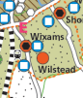

This is factually incorrect and is inaccurate.

Showing vague, poorly located blobs of roughly where allocations are is not helpful. Having spent more time looking at local policy maps relating to Wilstead parish it has shown the clear issue with the allocations HOU15, HOU16 and HOU17 in terms of coalescence.

The proposed development surrounding Wilstead is completely incompatible with the rural scene that has existed for centuries. The Parish Council has taken maps from the BBC “Changes to Policies” document dated April 2022 and merged Maps 8 and 11. It has also added in developments contained within the Local Plan for Central Bedfordshire.

The merger of all these proposals shows Wilstead surrounded by new housing with only small buffer areas shown. Wilshamstead Parish Council very strongly objects to this urbanisation of the area.

On the map on the following page the areas for development are shown with striped, pink vertical lines.

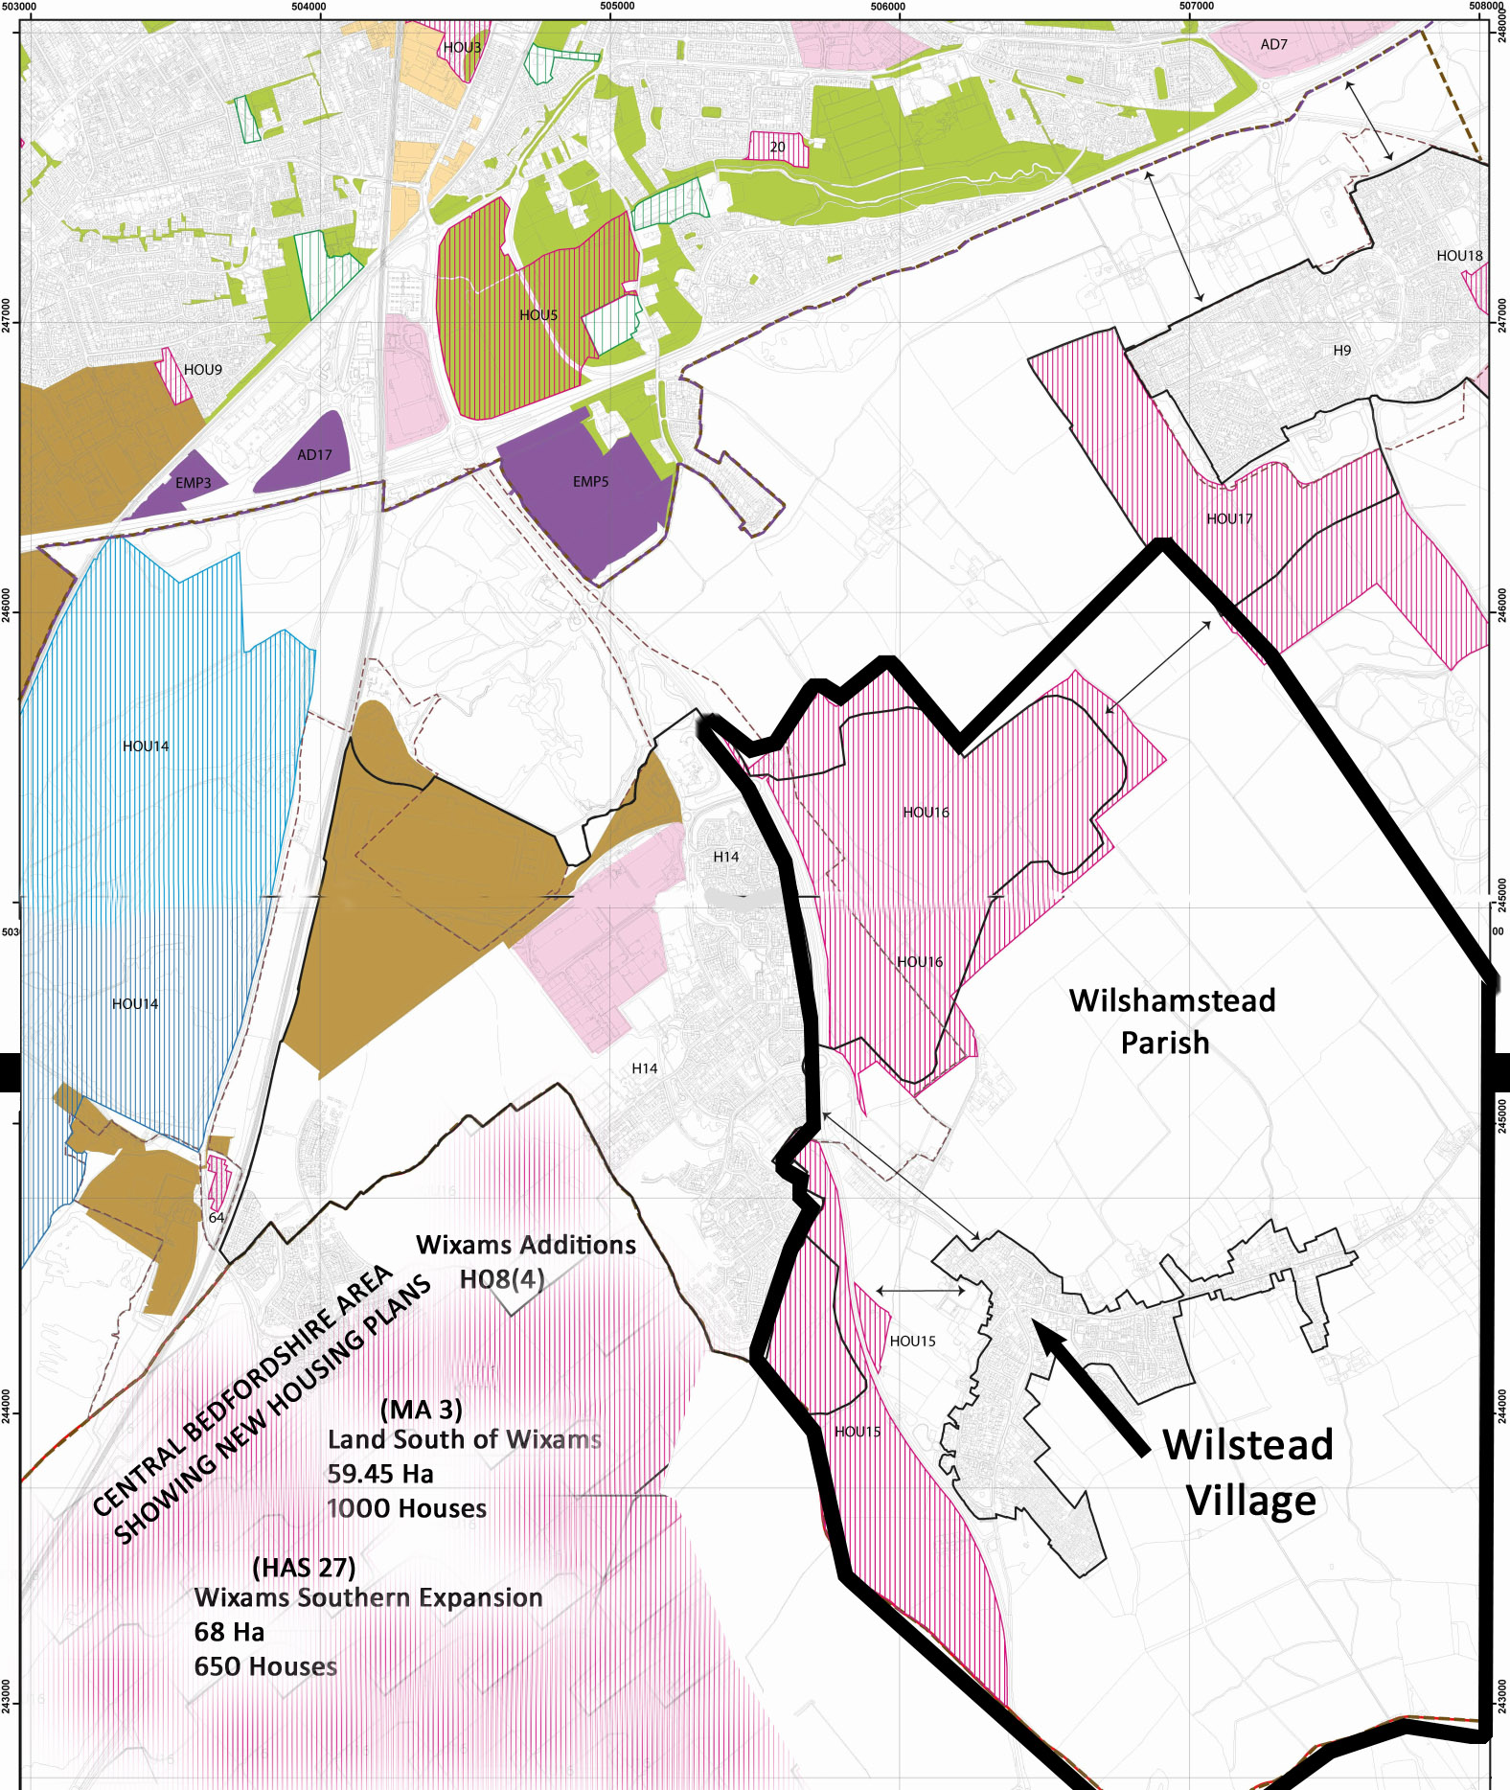
The Parish Council feel very strongly that there needs to be more done to protect the parishes, and Wilshamstead Parish in particular, to prevent the area becoming one large swathe of development.

Local Governance
The lack of forward planning on how this will be managed, will impact negatively on the established rural community of Wilstead. At no point is it clear in the consultation document on how the community governance arrangements will be managed for large housing development growth. Wilstead has first-hand experience of this, as Wixams grew, and then de-parished. The process brings many challenges, it is an uncertain time for residents, as well as being an exceptionally lengthy process with many complexities to navigate.

There needs to be clearer information on this set out within some part of the Local Plan around community governance, again with robust wording to ensure that communities can support their electorate and flourish.
SECTION 7 : NEIGHBOURHOOD PLAN
The proposed development of 2,100 houses within the parish boundary would directly contradict the first four objectives in the adopted Wilshamstead Neighbourhood Plan which are:

- To seek protection and enhancement of the countryside setting of the village, by ensuring separation from the urban edge whilst retaining access to the countryside.
- Identified green spaces, views and vistas and local wildlife habitats will be maintained and enhanced.
- To identify, protect and enhance village heritage assets and key public spaces, ensuring that any future development is sympathetic to the existing rural character of the village.
- To ensure any future housing responds to local needs, is of a high standard of design, and fits well into the context of the village in terms of type, mix, scale and character.

Thorough consultation was undertaken on the Neighbourhood Plan which demonstrates the value that local people place on the landscape and rural environment of the Parish. 95% of respondents agreed that the rural feel and access to the countryside are fundamental to the quality of life and community identity for Wilstead.

The Neighbourhood Plan for Wilstead was prepared to be in general conformity with the adopted Bedford Borough Local Plan 2030, having undergone extensive consultation with the community and stakeholders as well as BBC itself.

It includes policies to retain and protect the rural character of the Parish, to safeguard open spaces and prevent coalescence with Wixams, to ensure that new development is sensitively designed and that housing is suitable, to retain historic features and community facilities, to encourage local businesses and to tackle parking and traffic issues.

Five sites were identified in the Plan as “Strategic Gaps” to prevent coalescence with neighbouring communities. One of these Strategic Gaps is situated within the area identified under Policy HOU 16 and therefore this Policy is in direct contradiction to the Wilshamstead Neighbourhood Plan.

The Neighbourhood Plan is currently awaiting comments from the appointed examiner who has been made aware of this contradiction. It is expected that the Plan will go to referendum in the Autumn of 2022.

No housing allocations are being proposed in the Neighbourhood Plan, partly because the Local Plan 2030 did not require any allocations to be made, and partly because Wilstead has been subject to recent housing developments (over 100 houses or a more than 10% increase in numbers.). During consultation, residents reacted strongly against the notion of allocating any new developments of 10 houses or more, probably because of the existing level of new housing and a number of planning appeals that had been lodged in the Parish over recent years.

The Parish Council recognises that it is important to monitor the Neighbourhood Plan and check that progress is made towards meeting its objectives and policies and to respond to changes in the planning policy background. The Parish Council will consider
• if progress is being made to achieve the vision and the objectives of the Plan,
• if progress is being made towards the implementation of the policies in the Plan,
• if financial contributions available to the community arising from development are being targeted towards the identified plans and projects,
• if the Plan remains based on the most up to date information,
• if the Plan is being taken into account by Bedford Borough Council when determining planning applications.

The Parish Council will seek to work in partnership with Bedford Borough Council to liaise on future development of the Parish and will monitor progress on the Local Plan review and will consider whether to review the Neighbourhood Plan in line with the emerging Local Plan 2040.

If the emerging Local Plan 2040 is to require Wilstead Parish to accommodate further housing development in the period from 2030 to 2040, the Parish Council would prefer this requirement to be dealt with locally through a review of the Neighbourhood Plan which would allow much more local and focussed input from residents as to the location and type of development.

SECTION 8: SOUTH OF BEDFORD POLICY AREA

It is recognised by the Parish Council that development has to go somewhere in Bedford Borough but the policy of concentration of proposed development South of Bedford has to be accompanied by exhaustive investigation into, and subsequent close monitoring of, the infrastructure to support it.

At the moment the justification for development South of Bedford appears to be the future availability of Stewartby Hardwick and Wixams stations and the “easy” transport links to the A421.

However, the effect on A6 traffic has been poorly researched (e.g. it does not cover the increase in traffic likely from the Central Bedfordshire Local Plan which currently looks to be substantial in the northern part of that region) and the identified requirement for additional bus service, GPs, Primary and Secondary Schools and road improvements will require very substantial funding and, from experience at Wixams, unless very tightly monitored, will fail to meet the amounts required. This will result in compromises that will put extreme pressure on existing infrastructure which is already at capacity.

To concentrate on GP availability as one example : the GP to patient ratio is already extremely high. Wilstead Parish Council has attempted for 20 years to interest GP surgeries in the surrounding area to open new facilities in Wilstead or Wixams – without success. How it would be possible to recruit the 8 or more GPs required to support new developments in the Parish plus existing patients who can no longer be accommodated at the Ampthill surgeries due to Central Bedfordshire houses expansion is not explained.

In addition how is it planned to accommodate the extra traffic generated by the station at Wixams both in terms of existing road capacity and parking? Both are considered inadequate at present and will be made even worse by the proposed developments. Moreover, there have already been a number of children injured in the new Wixams development due to their existing issues with traffic. This remains a concern for the residents of Wilstead too, who already have a significant amount of through traffic coming from the A600 and which would likely increase with HOU17; people will most likely come through Wilstead and into Wixams for the new station as opposed to joining the A421 and the queues that already exist there at the Interchange intersection.

The new settlements proposed under different options of the draft Plan could have allowed for sufficient road infrastructure and parking from the start.

In light of the disproportionate strategic growth being focused on the south of Bedford area, Wilstead Parish Council feel it is important to comment on the subsidiary policy document, South of Bedford Policy Area Topic Paper.
Paragraph 3.1 states that “following consultation on the local plan strategy in the summer of 2021 a development strategy based on option 2b has been chosen as the preferred option”. Option 2b showed only 1,500 houses shared between Wootton, Kempston Rural, Elstow, Wilstead, Shortstown and Cotton End. The new draft Plan is therefore not based upon Option 2b as there are now 3,100 houses proposed in Wilstead and Shortstown alone.
Paragraph 4.3 makes no reference to the planted community woodland which covers an expansive area situated at Duck End in Wilstead parish, this appears an omission and the Parish Council joins with Elstow Parish Council in seeking the same level of designation for this woodland as any others mentioned. It is particularly concerning that development under HOU16 is proposed right alongside it.
Map 5 shows an extensive flood zone classified as 3a going right through the HOU16 Land at “East of Wixams” (i.e. North Wilstead) , which reads therefore that the flood implications in this area are currently very high. This would not be expected for an area allocated for 1,800 houses.
Maps 8 and 9, along with the accompanying Paragraphs in this part of the document are confusing. It is difficult to understand the point of all the different mapping particularly as the fields North of Wilstead are shown with no combined environmental biodiversity opportunity which is clearly incorrect.
Map 11 key Item 5 – Elstow South. This states that there is an application for infill. Subsequently in Appendix A it states that “This is an old brick pit for which a final restoration scheme is currently being considered which involves the filling of the site to original ground levels and restoration primarily to agriculture.” This sounds to be a plan despite the considerable objections raised by Elstow and Wilstead Parish Councils to the application based upon the enormous water expanse at this location which if it were no longer to be there would impact the local watercourse network management hugely and is already a site of environmental value and great recreational activity (course fishing).

SECTION 9 : MARSTON VALE SUPPLEMENTARY PLANNING DOCUMENT

The Parish Council support the principles within the Developing in the Forest of Marston Vale Supplementary Planning Document which is the planning policy document being prepared by both Central Bedfordshire and Bedford Borough Council local authorities.

The Parish Council also feel it is important to emphasise that tree planting should be within the open space aspects of development sites and remain on site for the benefit of those living at the development.

SECTION 10: CONCLUSION

Wilshamstead Parish Council continues to believe that all of the Borough should contribute to the housing need identified in Bedford Borough Council’s Local Plan 2040 but to an appropriate level for the size of the specific settlements in question Wilstead cannot be surrounded by new developments that will result in the overburdening of resources and unacceptable levels of through traffic.

The Parish Council are supportive of sharing some development across the rural communities surrounding Bedford, together with development within the urban area. This sharing should include some development in the communities north of Bedford and should not concentrate solely on development along the A421 corridor to the south of Bedford. The redevelopment of brownfield and urban sites would better suit young professionals commuting to London and would reduce the need for single occupancy vehicle travel into and around the Bedfordshire area. An urban plan would better suit sustainable transport models and de-carbonisation activities such as district heating networks and community solar projects.

The Parish Council recognises that the A421, A6, East West Rail and Midland Mainline railway are travel corridors which would support development along part of their routes south of Bedford but would also point out that the A6, East West Rail and Midland Mainline all go north from Bedford as well, and therefore should attract a fair share of development along this part of their routes.

Wilstead is a relatively small village with a rich history and heritage and local residents are attracted to the village by its position directly within the countryside. This rural character must not be affected by large-scale development in the future nor should its varied and significant biodiversity be damaged by such activity. We are in an era of climate change and as announced by the Mayor of Bedford on the 27th February 2019 we are now in a “Climate Emergency”. In particular it is asked that the Settlement Hierarchy review takes into account the anomalies in what has been produced so far. Wilstead is a relatively small size village now that it is separated from Wixams.

Policy HOU15 and Policy HOU16 provide a housing allocation for Wilstead that is far too high compared to the size of the community itself, it would represent a trebling in the size of the village housing numbers bringing with it significant damage to the biodiversity and rural nature of the area.

Policy HOU15 and Policy HOU16 have been represented in a misleading way to all stakeholders in this consultation process by not referring to Wilstead in any way.

The proposed development of 2,100 houses within the parish boundary would directly contradict the first four objectives in the adopted Wilshamstead Neighbourhood Plan.

There are a number of areas where the Parish Council has highlighted weak planning policy wording which will not safeguard and protect the existing local communities but instead weaken and fragment them.

All of the above contribute towards the strong objection that Wilshamstead Parish Council feels to the proposals in the Bedford Borough Local Plan for Submission 2040.

