Representation form for the Bedford Borough Local Plan 2040: Plan for Submission (Regulation 19 publication stage)

Please refer to the guidance notes available before completing this form.
Please return to Bedford Borough Council by 5pm on 29th July 2022.

This form has two parts –
Part A – Personal details: need only be completed once.
Part B – Your representation(s). Please fill in a separate sheet for each representation you wish to make.

Part A

1. Personal details* |  |  |  |  |  | 2. Agent’s details (if applicable)
*If an agent is appointed, please complete only the Title, Name and Organisation (if applicable) boxes below but complete the full contact details of the agent in 2.

Title
First name
Last name
Job title
Organisation
Address line 1
Line 2
Line 3
Line 4
Postcode
Telephone number
E-mail address
(where relevant)

Part B – Please use a separate sheet for each representation

Name or organisation:
3. To which part of the Local Plan does this representation relate?
Paragraph |  | 4.58 | Policy |  |  |  | Policies Map
4. Do you consider the Local Plan is :
4.(1) Legally compliant  4.(2) Sound |  |  |  | Yes  Yes |  |  |  |  |  |  |  | No  No | X
 |  |  |  |  |  |  |  |  |  |  |  |  | X
4 (3) Complies with the
Duty to co-operate Yes No

Please tick as appropriate
5. Please give details of why you consider the Local Plan is not legally compliant or is unsound or fails to comply with the duty to co-operate. Please be as precise as possible.
If you wish to support the legal compliance or soundness of the Local Plan or its compliance with the duty to co-operate, please also use this box to set out your comments.
The green ‘corridor’ will actually be an island with little natural access to wildlife due to the surrounding roads. From my house I have Visibility of the fields to the north of Elstow brook. Currently a wild life have with Red Kites nesting in the ash trees, Badgers and Deer regularly visiting my garden. Grass snakes in the meadow adjacent to the Church and Herons and Barn owls patrolling the surrounding areas.
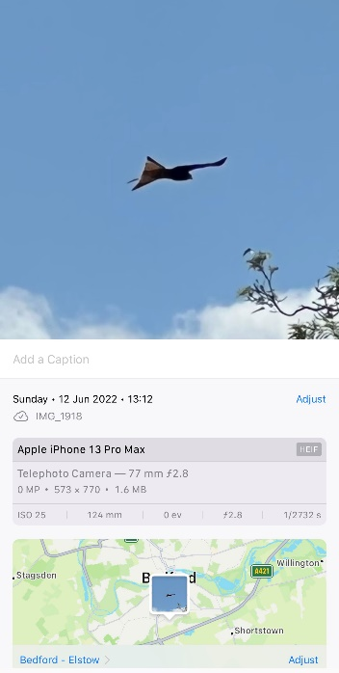
Additional developments and the infrastructure they require will add to the pressure on the existing communities of wild life. In addition to this the new developments will add to the volume of traffic entering Bedford from the south via any available route- this causes Elstow High st to be a rat run already.

6. Please set out the modification(s) you consider necessary to make the Local Plan legally compliant and sound, in respect of any legal compliance or soundness matters you have identified at 5 above. (Please note that non-compliance with the duty to co-operate is incapable of modification at examination). You will need to say why each modification will make the Local Plan legally compliant or sound. It will be helpful if you are able to put forward your suggested revised wording of any policy or text. Please be as precise as possible.
Provision needs to be made to guarantee wildlife continued access to the green corridor without having to run the gauntlet of the local highways. This will ensure it is not just a green Island with limited future prospects for long term sustainability .
Any additional developments will need to be carried out in such a manner as to be able to control/contain access to essential users only. Any additional infrastructure must be made to use existing corridors outside of the access to the green corridor

(Continue on a separate sheet /expand box if necessary)
Please note. In your representation you should provide succinctly all the evidence and supporting information necessary to support your representation and your suggested modification(s). You should not assume that you will have a further opportunity to make submissions.
After this stage, further submissions may only be made if invited by the Inspector, based on the matters and issues he or she identifies for examination.

7. If your representation is seeking a modification to the plan, do you consider it necessary to participate in examination hearing session(s)?
 | x | No, I do not wish to  participate in  hearing session(s) |  |  |  |  |  |  |  | Yes, I wish to participate in hearing session(s)
Please note that while this will provide an initial indication of your wish to participate in hearing session(s), you may be asked at a later point to confirm your request to participate.

8. If you wish to participate in the hearing session(s), please outline why you consider this to be necessary:
Please note the Inspector will determine the most appropriate procedure to hear those who have indicated that they wish to participate in hearing session(s). You may be asked to confirm your wish to participate when the Inspector has identified the matters and issues for examination.

