Response to the Consultation on the Draft Local Plan 2040 – observations and comments

North Brickhill Country Park
In the supporting papers to the Draft Local Plan, only two patches of land are shown as forming the Country Park. The surrounding area is shown as Green Infrastructure Network Opportunities. This is not correct. The whole of this area is the North Brickhill Country Park as evidenced by the map below.
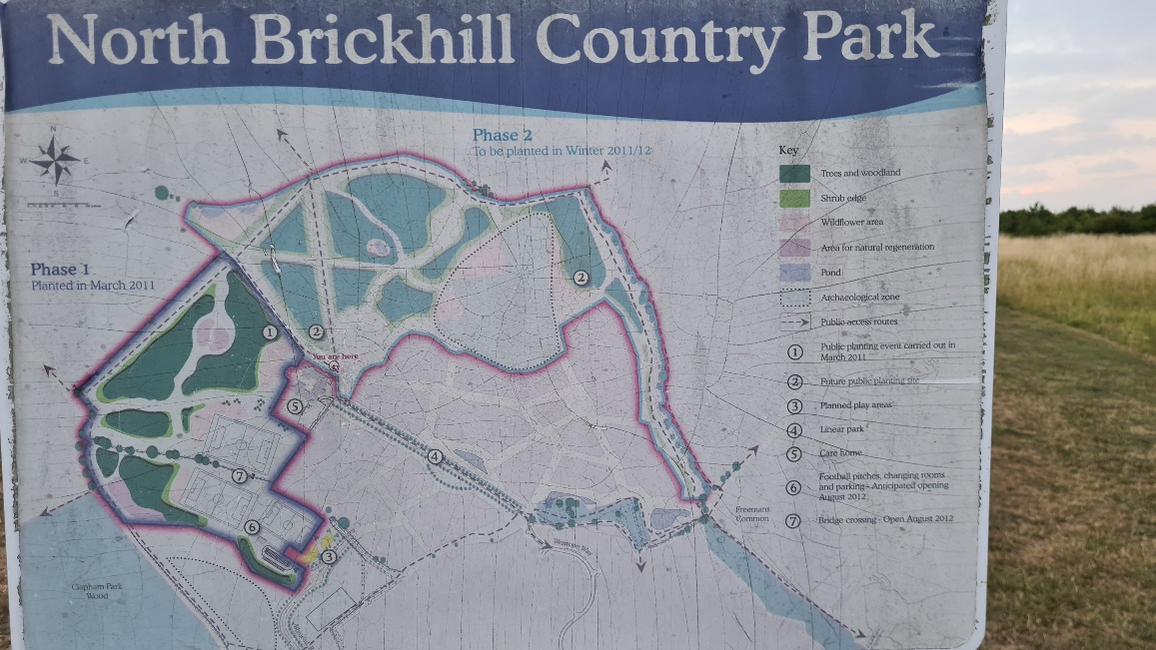

Policy EMP2 Former Playing Field, ARA Manton Lane
Under 4.0 Spatial Strategy and Site Allocation, this area is shown to be developed for industrial, warehousing and distribution uses. Can I request that positive pro-active plans and measures are put in place in advance of any such developments to reduce the impact of commercial traffic on Brickhill Drive. Brickhill Drive already suffers badly from heavy commercial vehicle usage.

