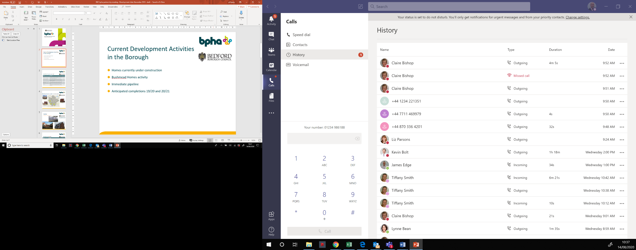**Greyfriars, Bedford**

**Car Park, Priory Court, Roise Court and Beckett Court**

Red Line Plan indicating land ownership

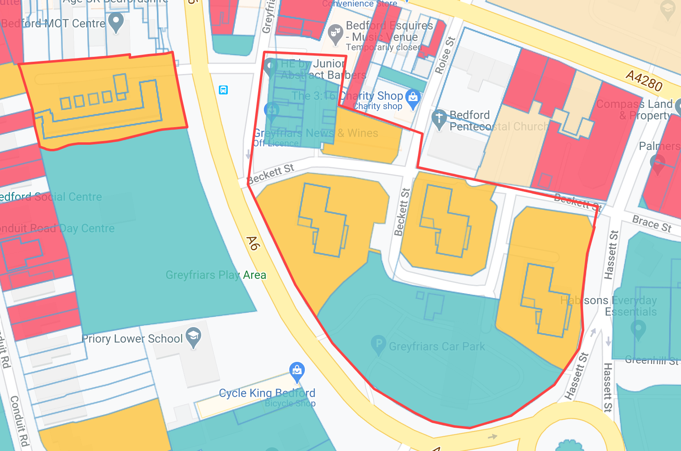Yellow = bpha, Turquoise = Bedford Borough Council

Crown copyright and database rights 2014 Ordnance Survey 0100055500